

SOPHGO Audio Hardware, Structural Design and Device Selection Instruction

Version: 1.0

Release date: 2023-12-26

© 2023 SOPHGO Inc.

Revision History

|  |  |  |
| --- | --- | --- |
| **Revision** | **Date** | **Description** |
| 1.0 | 2023/12/26 | Initial |
|  |  |  |
|  |  |  |
|  |  |  |
|  |  |  |
|  |  |  |
|  |  |  |

Contents

Revision History 2

Contents 3

1 Overview 4

1.1 Overview 4

1.2 Readership 4

2 Schematics and PCB Design 5

2.1 Schematics Design 5

2.1.1 SOC Audio GND 5

2.1.2 Audio In 5

2.1.3 Audio Out 6

2.2 PCB Design Requirements 6

2.2.1 SOC Audio GND Design 6

2.2.2 Audio In/Out Signal Design 6

2.2.3 AEC Signal Design 7

2.2.4 Amplifier Deisgn 7

3 Electroacoustic Device Selection 8

3.1 MIC Selection 8

3.2 AMP Selection 8

3.3 Speaker Selection 8

4 Notes on Structural Design 10

4.1 Notes on Structural Design for MIC 10

4.2 Notes on Structural Design for Speaker 10

5 Conclusion 11

# Overview

## Overview

This document contains recommendations on audio design for SOPHGO devices, including notes for schematic and PCB design, structural design, as well as component and device selection for MIC, Line In, Audio Out, AEC, etc.

## Readership

This document (guide) is targeted for the following engineering roles:

* Technical Support Engineers
* Single-board Hardware Development Engineers
* Structural Engineers
* Audio Engineers
* PCB Layout Designers

# Schematics and PCB Design

## Schematics Design

### SOC Audio GND

To avoid interference between SOC VDDC & TPU GND and Audio GND, it is imperative that all GND connected to the SOC side of the SOC Audio are connected to a discrete OR resistor or GND. The Audio In/Out terminals do not require a discrete GND. Please refer to your specific SOC reference schematics for designs.

### Audio In

If a microphone is used at the Audio In, it must be independently powered.

When using Line_in, resistive voltage division is required before connecting to SOPHGO’s SOC - usually, a 10,000 Ohm resistor in series and a 4,700 resistor to ground is used for this purpose.

When using MIC input, we would need to figure out whether we are using a single-ended MIC or a differential MIC.

If the former is used, we would then need to figure out the working voltage range of the MIC. SOPHGO do not support differential MIC - please contact us for evaluation.

In terms of power supply, as the SOPHGO SOC does not support MICBIAS, we recommend one of the following three approaches:

1. Resistive voltage-divided power supply: The 22uF/10uF capacitance is the minimum required; with 4.7uF + 0.1uF capacitors, the resistor should be rated at < 1,000 Ohms to satisfy the < 500uA power requirement for a normal MIC.

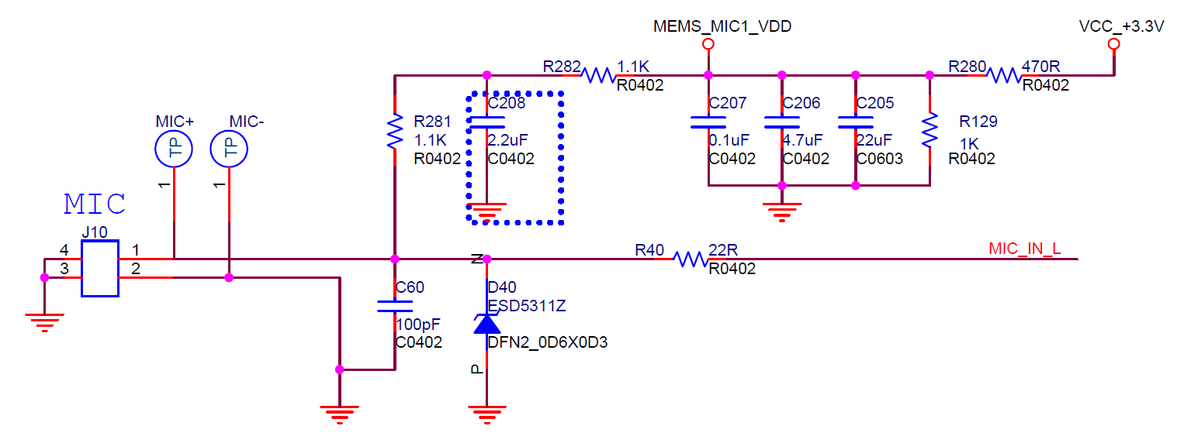

1. The 2.9V or 2.8V LDO output powered by analog voltage to Sensor has low noise and meets the requirements for MIC.
2. Other LDOs with low and simple loads only need to comply with the MIC’s required range of working voltage.
3. Out of the three approaches outlined above, we recommend the first, as it eases layout design and shows good result.

### Audio Out

SOPHGO’s Audio out has a DC bias voltage of 0.837V.

When drafting the schematics for AMP, simply follow conventional designs as SOPHGO SoCs do not require special design.

However, please take note to tune AMP for a reasonable amplification multiplier. It is recommended to use a 0dB audio file and max out its Audio Out Swing and, at this point, tune the AMP to a reasonable range where it produces an amplified output without distorted bass or peaks - the audio should have a high enough volume but no boom (audio boom would degrade the effect of the AEC).

## PCB Design Requirements

### SOC Audio GND Design

The 0R resistor for SOC Audio GND and SOC GND should be reasonably far from the SOC core region’s GND (SOC VDDC & TPU GND is noisy).

### Audio In/Out Signal Design

The Audio In’s isolation capacitor should be close to the SOC end. If there are two Audio Out’s isolation capacitors, one should be close to the SOC end and the other close to the AMP end; if there is only one available, it should be close to the AMP end. Routing going towards the Audio In/Out should be as far away from power components and routing as possible (and likewise for signal lines for level changes, i.e., PWM/CLK/IIC/SPI/UART). The entirety of the Audio signal line should be GND wrapped.

### AEC Signal Design

AEC devices and routing should stay close to the SOC line and its entirety should be GND wrapped.

### Amplifier Design

Routing going towards the amplifier’s input and output ends should not be crossed and the power supply capacitor should be as close to the amplifier as possible. The direct routing going between the amplifier output and the speaker socket should have at least 2 VIA for improved flux capacity.

# Electroacoustic Device Selection

## MIC Selection

In consideration of cost, it is recommended to use leaded single-ended analog MICs, in compliance with the following parameters:

1. SNR (Signal-to-Noise Ratio) should be ≥58dB (most MIC on the market should fit this requirement).
2. Sensitivity should be roughly -26dB.
3. It is suggested to select omnidirectional MICs. Directional MICs with limited pick-up angles may affect MIC reception volumes and AEC, but are nonetheless acceptable for specialized product designs.

## AMP Selection

You may use any general-purpose AMP available, provided that the AMP’s output power matches with that of the speaker.

If an IIS AMP is desired, please be sure to consult SOPHGO for in-depth analysis of its effects on AEC. This is because IIS AMP is only capable for sampling from behind the AMP where the audio signal waves are not directly transmitted and require conversion. This may harm AEC.

If there are no specific AEC requirements then any conventional design should work.

## Speaker Selection

Recommendations for the parameters of the Speaker are as follows:

1. Sound Pressure Level (SPL): ≥89dB; the larger the SPL value, the more sensitive the speaker.
2. Fundamental Frequency of the Unit (F0): <1KHz. Taking into account the combination of the structure of the sound cavity, F0 may be positively offset (the fundamental frequency after this offset should not exceed 1KHz) - therefore, the base frequency of the unit should be rated at around 600Hz. The flatter the frequency response curve in the high-frequency band (>1KHz) the better - try to avoid peak pulse waveforms in this frequency band.
3. Rated impedance: 4Ω±15% for 2W speakers, 8Ω±15% for 1W speakers.
4. Total harmonic distortion (THD): ≤10%.
5. Sound cavity: Rear cavity recommended.

# Notes on Structural Design

## Notes on Structural Design for MIC

Items of note:

1. MIC must come with a discrete audio cavity design, as it can improve the range of reception at identical volumes. The MIC devices should come with anti-vibration bushings - the thicker the bushings, the better the anti-vibration characteristics.
2. The MIC should face the opposite direction of the Speaker. If this is not possible, maximize the angle between the two devices to minimize audio signal coupling.
3. The structural reception hole for the MIC should be round with a diameter of the hole is normally 0.8-1.2mm. Excessive sizing may degrade the audio cavity.

## Notes on Structural Design for Speaker

Items of note:

1. The Speaker must come with a discrete audio cavity design.
2. The Speaker must come with rubber padding for anti-vibration with (from experience) a thickness of 1.2mm. Excessively thin padding may harm audio quality of the Speaker. Moreover, Mechanical vibration may cause issues such as booming and poor AEC in the MIC. The padding should surround both the perimeter of the Speaker as well as its non-diaphragmed area in the front.
3. The Speaker diaphragm should maintain a 1-1.2mm gap between its maximal point of movement and the audio cavity. It is imperative that the diaphragm does not touch the inside of the audio cavity.
4. The total area of the perforation of the Speaker grill should amount to 10-15% of the area of the diaphragm. The size of the perforation should be as big as aesthetic allows.
5. No matter the method of Speaker mounting (screws or glue), the size of the audio cavity should take into account of the size of the padding such that it could fully function.

# Conclusion

Many manufacturers and engineers consider audio processing algorithm solely dictates audio quality. Audio quality engineering is one that involves systematic engineering - hardware design, device characteristics, structural design, and algorithm design are equally important in building a product that meets expectation.